1. Download the **kubectl** executable from below link

https://dl.k8s.io/release/v1.28.2/bin/windows/amd64/kubectl.exe

1. Create a folder in your desktop called kubernetes and move the download file to this folder.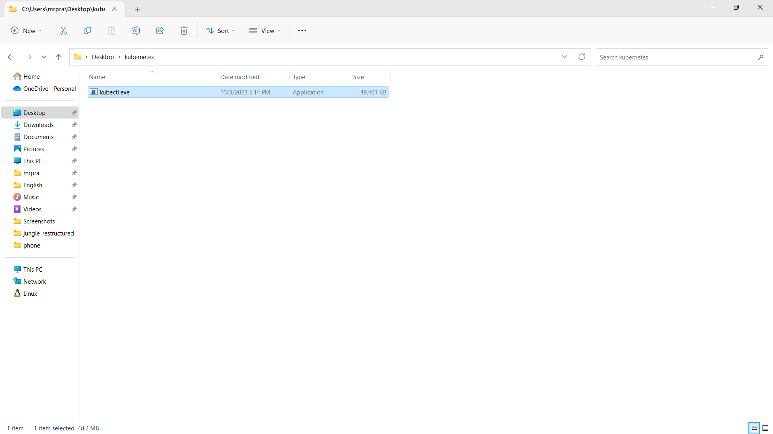
2. Now right click on this file, More Options>Properties. Then copy the Location of this file. 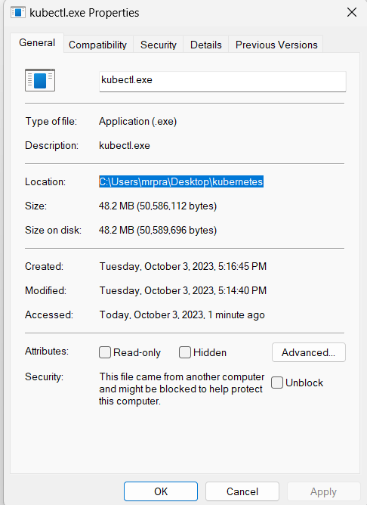
3. Now search for environment in the search box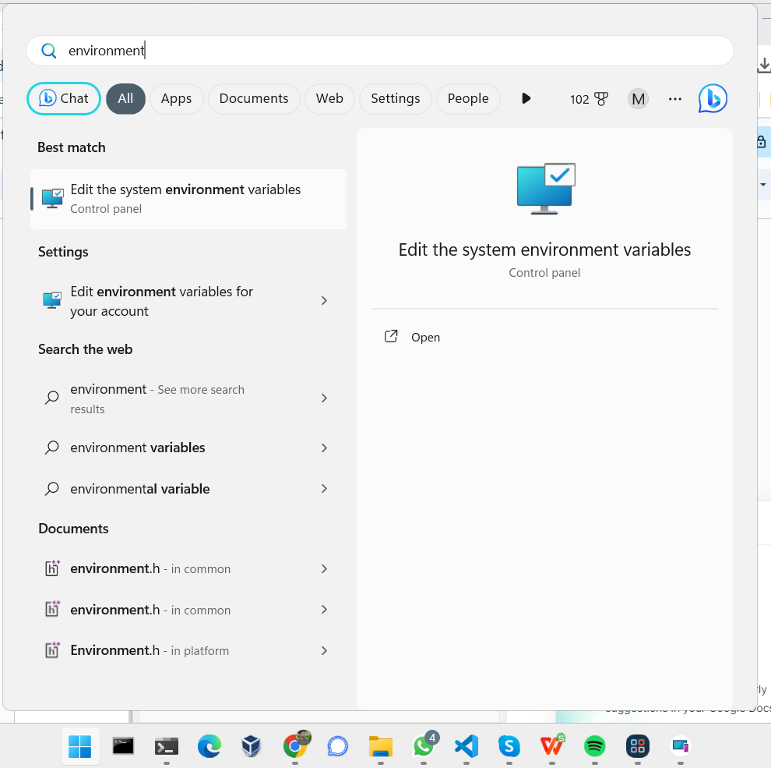
4. Open the first result
5. Now click on Environment Variables Again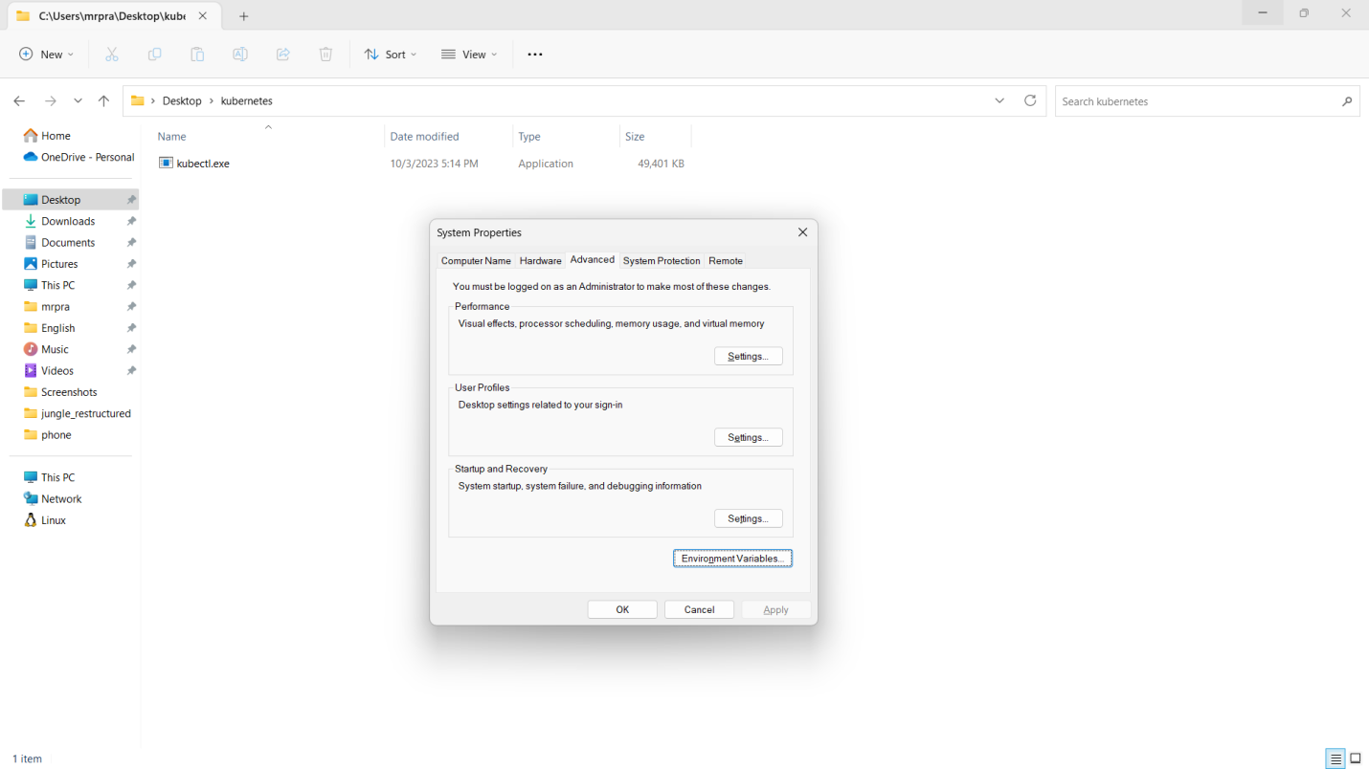
6. Select the **Path** variable and click on **EDIT**.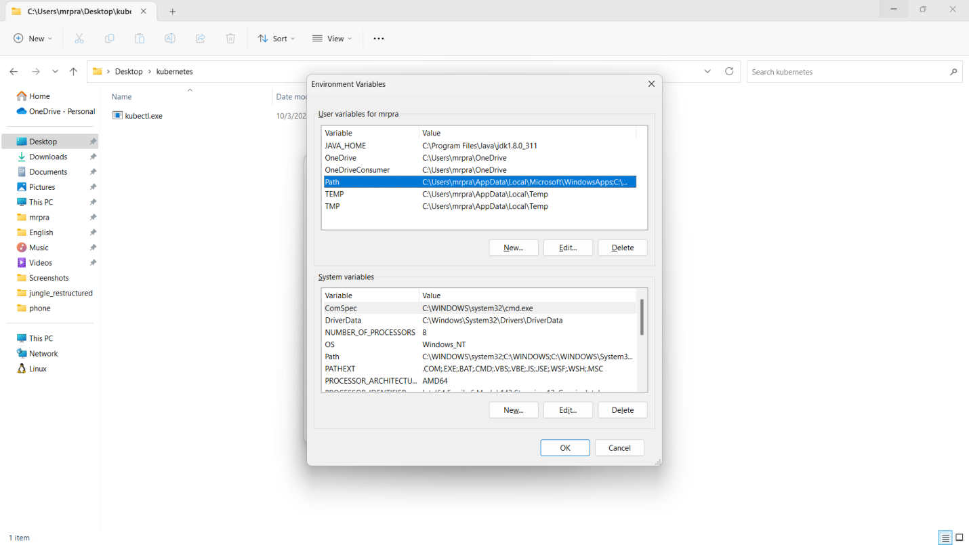
7. Now click on **NEW** and paste the Location of kubectl.exe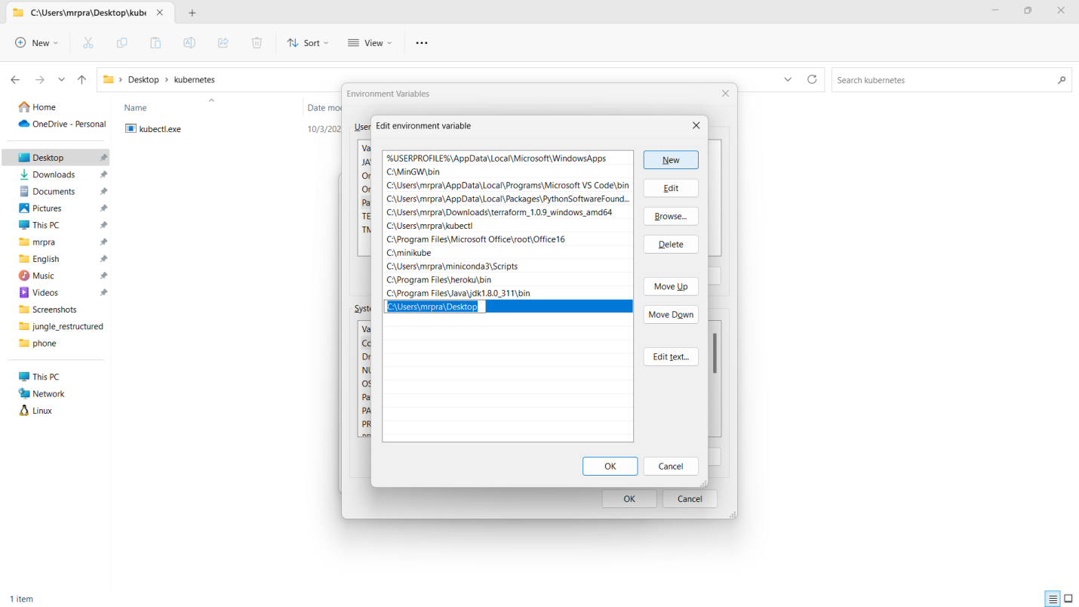
8. Click OK>OK>Apply.
9. Now open command prompt and you can run

$ kubectl version

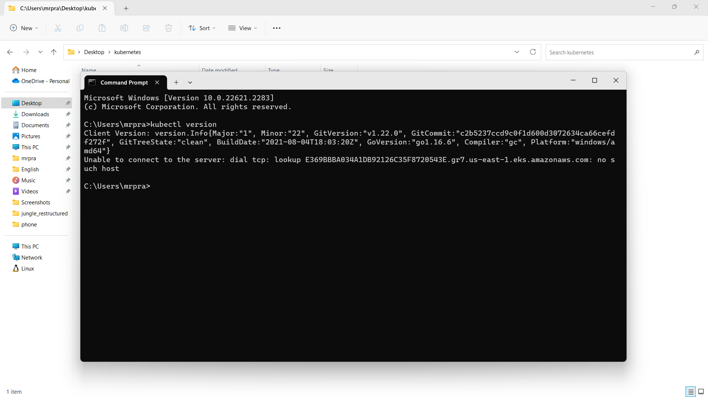

1. The installation of kubectl is successful.